**PROJECT**

**ON**

**ADVANCED STATISTICS**

**By SHAJIL FERNANDEZ**

**02-07-2023**

**Table of Contents:**

**Problem 1**

* 1. What is the probability that randomly chosen player would suffer an injury? **Pg -5**
  2. What is the probability that a player is a forward or a winger? **Pg -5**
  3. What is the probability that a randomly chosen player plays in a striker position and has a foot injury? **Pg -5**
  4. What is the probability that a randomly chosen injured player is a striker? **Pg -6**
  5. What is the probability that a randomly chosen injured player is either a forward or an attacking midfielder? **Pg -6**

**Problem 2**

**2.1** What are the probabilities of a fire, a mechanical failure, and a human error respectively? **Pg - 7**

1. Fire **Pg -7**
2. Mechanical Failure **Pg -7**
3. Human error **Pg -7**

**2.2** What is the probability of a radiation leak? **Pg -8**

**2.3** Suppose there has been a radiation leak in the reactor for which the definite cause is not known. What is the probability that it has been caused by: **Pg -8**

1. Fire **Pg -8**
2. Mechanical Failure **Pg -8**
3. Human error **Pg -9**

**Problem 3**

**3.1** What proportion of the gunny bags have a breaking strength less than 3.17 kg per sq cm? **Pg -9**

**3.2** What proportion of the gunny bags have a breaking strength at least 3.6 kg per sq cm.? **Pg -10**

**3.3** What proportion of the gunny bags have a breaking strength between 5 and 5.5 kg per sq cm.? **Pg -10**

**3.4** What proportion of the gunny bags have a breaking strength NOT between 3 and 7.5 kg per sq cm.? **Pg -11**

**Problem 4**

**4.1** What is the probability that a randomly chosen student gets a grade below 85 on this exam? **Pg -11**

**4.2** What is the probability that a randomly selected student scores between 65 and 87? **Pg -12**

**4.3** What should be passing cut-off so that 75% of the studentsclear the exam?**Pg -12**

**Problem 5**

**5.1** Earlier experience of Zingaro with this particular client is favorable as the stone surface was found to be of adequate hardness. However, Zingaro has reason to believe now that the unpolished stones may not be suitable for printing. Do you think Zingaro is justified in thinking so? **Pg -13**

1. Unpolished t test **Pg -13**
2. Treated and Polished **Pg -14**

**5.2** Is the mean hardness of the polished and unpolished stones the same? **Pg -14**

**Problem 6**

**6.1 Problem on** Aquarius health club **Pg -15**

**Problem 7**

**7.1** Test whether there is any difference among the dentists on the implant hardness. State the null and alternative hypotheses. Note that both types of alloys cannot be considered together. You must state the null and alternative hypotheses separately for the two types of alloys.? **Pg -16**

1. Alloy 1 **Pg -16**
2. Alloy 2 **Pg -16**

**7.2** Before the hypotheses may be tested, state the required assumptions. Are the assumptions fulfilled? Comment separately on both alloy types.?  **Pg -17**

1. Alloy 1 **Pg -17**
2. Alloy 2 **Pg -17**

**7.3** Irrespective of your conclusion in 2, we will continue with the testing procedure. What do you conclude regarding whether implant hardness depends on dentists? Clearly state your conclusion. If the null hypothesis is rejected, is it possible to identify which pairs of dentists differ? **Pg -17**

1. Alloy 1 **Pg -18**
2. Alloy 2 **Pg -19**

**7.4** Now test whether there is any difference among the methods on the hardness of dental implant, separately for the two types of alloys. What are your conclusions? If the null hypothesis is rejected, is it possible to identify which pairs of methods differ?

1. Alloy 1 **Pg -20**
2. Alloy 2 **Pg -21**

**7.5** Now test whether there is any difference among the temperature levels on the hardness of dental implant, separately for the two types of alloys. What are your conclusions? If the null hypothesis is rejected, is it possible to identify which levels of temperatures differ? **Pg -22**

1. Alloy 1 **Pg -22**
2. Alloy 2 **Pg -23**

**7.6** Consider the interaction effect of dentist and method and comment on the interaction plot, separately for the two types of alloys? **Pg -24**

1. Alloy 1 **Pg -24**
2. Alloy 2 **Pg -25**

**7.7** Now consider the effect of both factors, dentist, and method, separately on each alloy. What do you conclude? Is it possible to identify which dentists are different, which methods are different, and which interaction levels are different? **Pg -27**

1. Alloy 1 **Pg -27**
2. Alloy 2 **Pg -28**

**Problem 1**

A physiotherapist with a male football team is interested in studying the relationship between foot injuries and the positions at which the players play from the data collected.

|  |  |  |  |  |  |
| --- | --- | --- | --- | --- | --- |
|  | Striker | Forward | Attacking Midfielder | Winger | **Total** |
| Players Injured | 45 | 56 | 24 | 20 | **145** |
| Players Not Injured | 32 | 38 | 11 | 9 | **90** |
| **Total** | **77** | **94** | **35** | **29** | **235** |

* 1. What is the probability that a randomly chosen player would suffer an injury?

**Ans:** The probability for which a randomly chosen player would suffer an injury is **61.70%.**

Calculation: **Total number of players injured (145) / Total number of players (235) * 100 = 61.70%**

* 1. What is the probability that a player is a forward or a winger?

**Ans:** The probability that a player is a forward or a winger is **52.34%.**

Calculation: **Forward 94/235 + Winger 29/235 = 123/235 = 52.34%**

* 1. What is the probability that a randomly chosen player plays in a striker position and has a foot injury?

**Ans:** The probability that a randomly chosen player plays in a striker position and has a foot injury is **19.14%.**

Calculation: **striker position and has a foot injury (45) / Total number of players (235) = 19.14%**

* 1. What is the probability that a randomly chosen injured player is a striker?

**Ans**: The probability that a randomly chosen injured player is a striker is **31.03%.**

Calculation**: Injured striker (45) / Total number of injured players (145) *100 = 31.03%**

**1.5** What is the probability that a randomly chosen injured player is either a forward or an attacking midfielder?

**Ans**: The probability that a randomly chosen injured player is either a forward or an attacking midfielder is **55.17%.**

Calculation**: Forward 56/145 + Attacking Midfielder 24/145 = 80/145 = 55.17%**

**Problem 2**

An independent research organization is trying to estimate the probability that an accident at a nuclear power plant will result in radiation leakage. The types of accidents possible at the plant are, fire hazards, mechanical failure, or human error. The research organization also knows that two or more types of accidents cannot occur simultaneously.

According to the studies carried out by the organization, the probability of a radiation leak in case of a fire is 20%, the probability of a radiation leak in case of a mechanical 50%, and the probability of a radiation leak in case of a human error is 10%. The studies also showed the following;

* The probability of a radiation leak occurring simultaneously with a fire is 0.1%.
* The probability of a radiation leak occurring simultaneously with a mechanical failure is 0.15%.
* The probability of a radiation leak occurring simultaneously with a human error is 0.12%.

On the basis of the information available, answer the questions below:

**Probability of radiation leak given Fire**

P(Radiation Leak | Fire) = 20% = 0.2

**Probability of radiation leak given Mechanical failure**

P(Radiation Leak | Mechanical failure) = 50% = 0.5

**Probability of radiation leak given Human error**

P(Radiation Leak | Human error) = 10% = 0.1

**Probability of radiation leak occurring simultaneously with a fire**

P(Radiation Leak ∩ Fire) = 0.1% = 0.001

**Probability of radiation leak occurring simultaneously with a Mechanical failure**

P(Radiation Leak ∩ Mechanical failure) = 0.15% = 0.0015

**Probability of radiation leak occurring simultaneously with a Human error**

P(Radiation Leak ∩ Human error) = 0.12% = 0.0012

**2.1** What are the probabilities of a fire, a mechanical failure, and a human error respectively?

**Ans**:

P(A|B) = P(A ∩ B) / P(B)

Therefore, P(B) = P(A ∩ B) / P(A|B)

1. **Fire:**

Prob of fire P(F) = P(Radiation Leak ∩ Fire) / P(Radiation Leak | Fire)

Prob of fire P(F) = 0.001 / 0.2 = **0.005 or 0.5%**

**Therefore, the probability of a fire is** **0.005 or 0.5%.**

1. **Mechanical Failure**:

Prob of Mechanical Failure P(M) = P(Radiation Leak ∩ Mechanical failure) / P(Radiation Leak | Mechanical failure)

Prob of Mechanical failure P(M) = 0.0015 / 0.5 = **0.003 or 0.3%**

**Therefore, the probability of a mechanical failure is 0.003 or 0.3%.**

1. **Human error**:

Prob of Human error P(H) = P(Radiation Leak ∩ Human error) / P(Radiation Leak | Human error)

Prob of Human error P(H) = 0.0012 / 0.1 = **0.012 or 1.2%**

**Therefore, the probability of a human error is** **0.012 or 1.2%.**

**2.2** What is the probability of a radiation leak?

**Ans**: The probability of a radiation leak is **0.0037 or 0.37%.**

**Calculation:**

Prob of Radiation Leak P(R) = P(Radiation Leak ∩ Fire) + P(Radiation Leak ∩ Mechanical failure) + P(Radiation Leak ∩ Human error)

Prob of Radiation Leak P(R) = 0.001 + 0.0015 + 0.0012 = **0.0037 or 0.37%**

**2.3** Suppose there has been a radiation leak in the reactor for which the definite cause is not known. What is the probability that it has been caused by:

* A Fire.
* A Mechanical Failure.
* A Human Error.

**Ans:**

P(A|B) = P(A ∩ B) / P(B)

1. **Fire:**

P(Fire | Radiation Leak) = P(Radiation Leak ∩ Fire) / P(Radiation Leak)

P(Fire | Radiation Leak) = 0.001 / 0.0037 = **0.27 or 27.03%**

Therefore, the probability that it has been caused by a Fire is **0.27 or 27.03%.**

1. **Mechanical Failure:**

P(Mechanical failure | Radiation Leak) = P(Radiation Leak ∩ Mechanical failure) / P(Radiation Leak)

P(Mechanical failure | Radiation Leak) = 0.0015 / 0.0037 = **0.41 or 40.54%**

Therefore, the probability that it has been caused by a Mechanical Failure is **0.41 or 40.54%.**

1. **Human Error:**

P(Human error | Radiation Leak) = P(Radiation Leak ∩ Human error) / P(Radiation Leak)

P(Human error | Radiation Leak) = 0.0012 / 0.0037 = **0.32 or 32.43%**

Therefore, the probability that it has been caused by a Human error is **0.32 or 32.43%.**

**Problem 3:**

The breaking strength of gunny bags used for packaging cement is normally distributed with a mean of 5 kg per sq. centimeter and a standard deviation of 1.5 kg per sq. centimeter. The quality team of the cement company wants to know the following about the packaging material to better understand wastage or pilferage within the supply chain; Answer the questions below based on the given information; **(Provide an appropriate visual representation of your answers, without which marks will be deducted)**

**3.1** What proportion of the gunny bags have a breaking strength less than 3.17 kg per sq cm?

**Ans**: Proportion of the gunny bags having a breaking strength less than 3.17 kg per sq cm is **0.11**

Visualizing the proportion of the gunny bags having a breaking strength less than 3.17 kg per sq cm

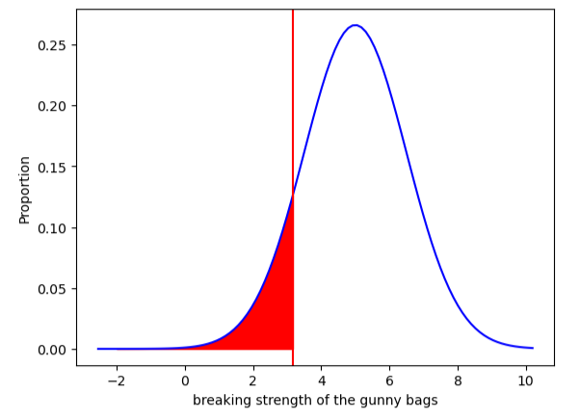

**3.2** What proportion of the gunny bags have a breaking strength at least 3.6 kg per sq cm.?

**Ans**: Proportion of the gunny bags having a breaking strength at least 3.6 kg per sq cm is **0.82**

Visualizing the proportion of the gunny bags having a breaking strength at least 3.6 kg per sq cm

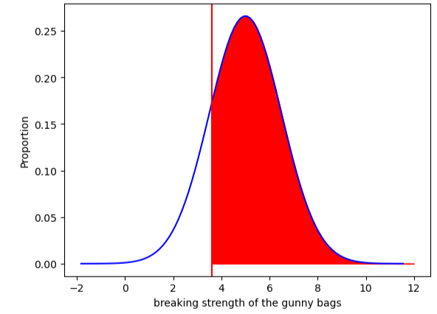

**3.3** What proportion of the gunny bags have a breaking strength between 5 and 5.5 kg per sq cm.?

**Ans**: Proportion of the gunny bags having a breaking strength between 5 and 5.5 kg per sq cm is **0.13**

Visualizing the proportion of the gunny bags having a breaking strength between 5 and 5.5 kg per sq cm

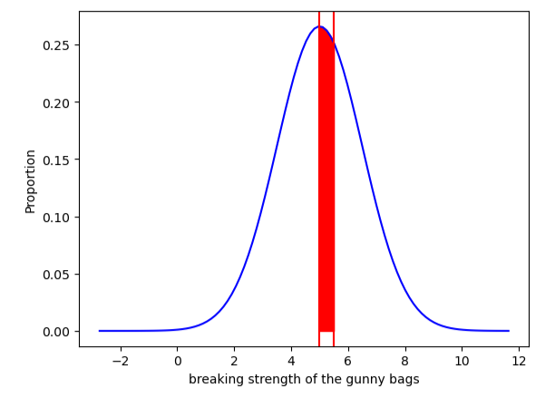

**3.4** What proportion of the gunny bags have a breaking strength NOT between 3 and 7.5 kg per sq cm.?

**Ans**: Proportion of the gunny bags having a breaking strength NOT between 3 and 7.5 kg per sq cm is **0.14**

Visualizing the proportion of the gunny bags having a breaking strength NOT between 3 and 7.5 kg per sq cm

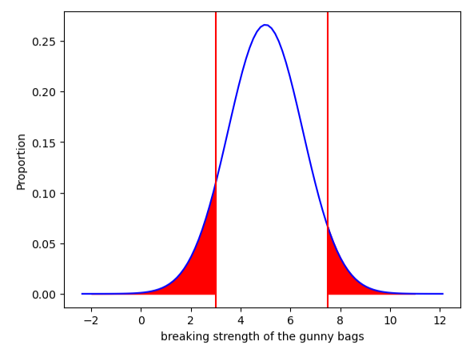

**Problem 4:**

Grades of the final examination in a training course are found to be normally distributed, with a mean of 77 and a standard deviation of 8.5. Based on the given information answer the questions below.

**4.1** What is the probability that a randomly chosen student gets a grade below 85 on this exam?

**Ans:** The probability that a randomly chosen student gets a grade below 85 on this exam is **0.83 or 83%.**

Visualizing the probability that a randomly chosen student gets a grade below 85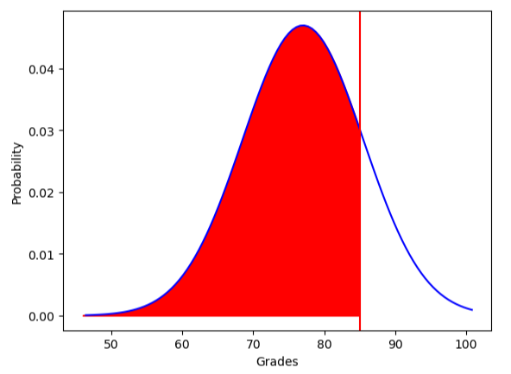

**4.2** What is the probability that a randomly selected student scores between 65 and 87?

**Ans:** The probability that a randomly selected student scores between 65 and 87 is **0.8 or 80%.**

Visualizing the probability that a randomly selected student scores between 65 and 87

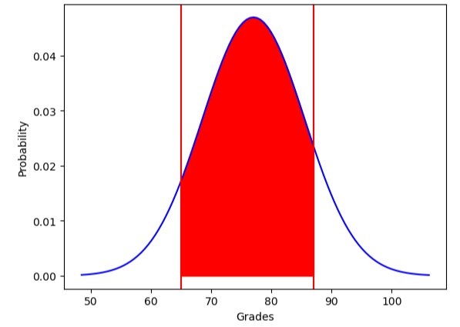

**4.3** What should be the passing cut-off so that 75% of the students clear the exam?

**Ans:** The passing cut-off so that 75% of the students clear the exam is **71.27.**

Visualizing the passing cut-off so that 75% of the students clear the exam

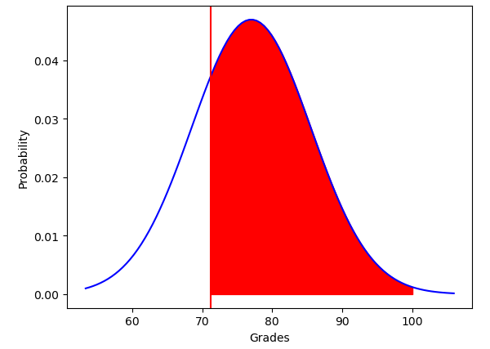

**Problem 5:**

Zingaro stone printing is a company that specializes in printing images or patterns on polished or unpolished stones. However, for the optimum level of printing of the image the stone surface has to have a Brinell's hardness index of at least 150. Recently, Zingaro has received a batch of polished and unpolished stones from its clients. Use the data provided to answer the following (assuming a 5% significance level);

**5.1** Earlier experience of Zingaro with this particular client is favorable as the stone surface was found to be of adequate hardness. However, Zingaro has reason to believe now that the unpolished stones may not be suitable for printing. Do you think Zingaro is justified in thinking so?

**Ans:**

mu = 150

n = 75

Alpha = 0.05

1. **Unpolished t test:**

Ho = unpolished stones may be suitable for printing i.e., >= 150

Ha = unpolished stones may not be suitable for printing i.e., < 150

**As standard deviation of population not known, we can opt t test; t test = (x_bar - mu) / (s/np.sqrt(n))**

The value of the t test statistic = **-4.1646296**

Critical value = **-1.67**

P value = **8.34257399e-05**

**Conclusion**: **As p value < α, we can reject the null hypothesis with 95% confidence. Zingaro is justified in this case i.e., unpolished stones are not suitable for printing and has Brinell's hardness index less than 150.**

1. **Treated and Polished:**

Ho = Polished stone surface have a Brinell's hardness index of at least 150 (>=150)

Ha = Polished stone surface DO NOT have a Brinell's hardness index of at least 150 (<150)

The value of the t test statistic = **- 1.22891066**

Critical value = **-1.67**

P value = **2.22998968e-01**

**Conclusion**: **As p value > α, we Fail to reject the null hypothesis. i.e., Polished stone surface has a Brinell's hardness index of at least 150.**

**5.2** Is the mean hardness of the polished and unpolished stones the same?

**Ans:**

Ho = mean hardness of the polished and unpolished stones is the same

Ha = mean hardness of the polished and unpolished stones is NOT the same

The value of the t test statistic = **-3.2422320501414053**

P value = **0.0014655150194628353**

**Conclusion: As p value < α, we can Reject the null hypothesis.**

**i.e., Mean hardness of the polished and unpolished stones are NOT the same in this case.**

**Problem 6:**

Aquarius health club, one of the largest and most popular cross-fit gyms in the country has been advertising a rigorous program for body conditioning. The program is considered successful if the candidate is able to do more than 5 push-ups, as compared to when he/she enrolled in the program. Using the sample data provided can you conclude whether the program is successful? (Consider the level of Significance as 5%)

Note that this is a problem of the paired-t-test. Since the claim is that the training will make a difference of more than 5, the null and alternative hypotheses must be formed accordingly.

**Ans:**

**Ho = training will not make any difference (<=5)**

**Ha = training will make a difference of more than 5 (>5)**

α = 0.05

The value of the t test statistic = **-19.322619811082458**

P value = **1.1460209626255983e-35**

**Conclusion**: **As p value < α, we can Reject the null hypothesis. i.e., the training will make a difference of more than 5 push-ups, as compared to when he/she enrolled in the program.**

**Problem 7:**

Dental implant data: The hardness of metal implant in dental cavities depends on multiple factors, such as the method of implant, the temperature at which the metal is treated, the alloy used as well as on the dentists who may favour one method above another and may work better in his/her favourite method. The response is the variable of interest.

**7.1** Test whether there is any difference among the dentists on the implant hardness. State the null and alternative hypotheses. Note that both types of alloys cannot be considered together. You must state the null and alternative hypotheses separately for the two types of alloys.?

1. **Alloy 1:**

Ho = There is NO difference among the dentists on the implant hardness

Ha = There is difference among the dentists on the implant hardness

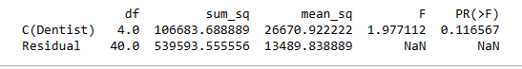

The value of the F statistic = **1.977112**

P value = **0.116567**

**Conclusion: As p value > α, we Fail to Reject the null hypothesis. i.e., There is NO difference among the dentists on the implant hardness of Alloy 1 type.**

1. **Alloy 2:**

Ho = There is NO difference among the dentists on the implant hardness

Ha = There is difference among the dentists on the implant hardness

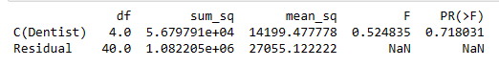

The value of the F statistic = **0.524835**

P value = **0.718031**

**(Normally distributed as all p values are > 0.05, except Dentist_4 whose p value is less when compared with Shapiro test. Therefore, the result may be slightly subjected to variation.**

**Conclusion: As p value > α, we Fail to Reject the null hypothesis. i.e., There is NO difference among the dentists on implant hardness of Alloy 2 type as well.**

**7.2** Before the hypotheses may be tested, state the required assumptions. Are the assumptions fulfilled? Comment separately on both alloy types.?

**Ans:**

1. **Alloy 1:**

* Samples were random and independent.
* Samples were continuous and normally distributed (satisfied Shapiro-Wilk test).
* Variances of the populations were equal (satisfied Levene’s test).

1. **Alloy 2:**

* Samples were random and independent.
* Samples were continuous and normally distributed, except for “Dentist_4” sample, as the p value is less than 0.05, hence “Dentist_4” sample was not normally distributed.
* Variances of the populations were equal (satisfied Levene’s test).

**7.3** Irrespective of your conclusion in 2, we will continue with the testing procedure. What do you conclude regarding whether implant hardness depends on dentists? Clearly state your conclusion. If the null hypothesis is rejected, is it possible to identify which pairs of dentists differ?

**Ans:**

One Way Anova to check whether implant hardness depends on dentist.

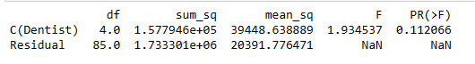

**Conclusion: We are about 89% sure that the implant hardness depends on dentists.**

1. **Alloy 1:**

Ho = implant hardness depends on dentists

Ha = implant hardness Does NOT depend on dentists



The value of the F statistic = **1.977112**

P value = **0.116567**

**Conclusion: As p value > α, we Fail to Reject the null hypothesis. i.e., implant hardness depends on dentists of Alloy 1 type.**

**Homogeneous:**

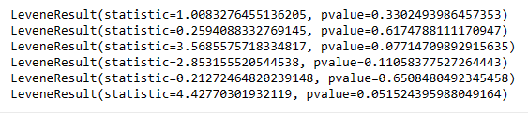

**All of the p values are above 0.05, hence, satisfies homogeneity.**

**Visualization:**

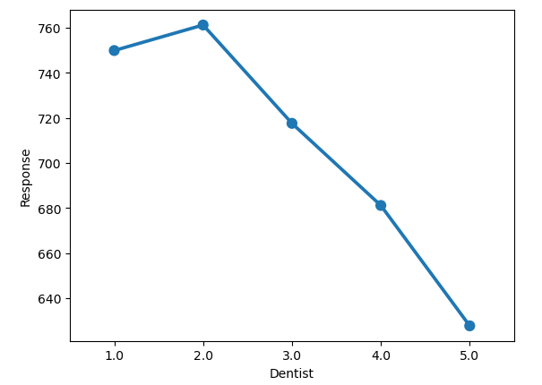

**Insights:**

* Dentist 2 has the highest response rate when compared with other dentists.
* Dentist 5 has least response rate.
* Dentist 1 is the second highest when compared to response rate.
* There is a decline in response rate from Dentist 3 onwards.

1. **Alloy 2:**

Ho = implant hardness depends on dentists

Ha = implant hardness Does NOT depend on dentists



The value of the F statistic = **0.524835**

P value = **0.718031**

**Conclusion: As p value > α, we Fail to Reject the null hypothesis. i.e., implant hardness depends on dentists of Alloy 2 type.**

**Homogeneous:**

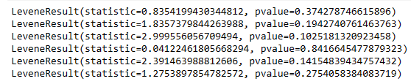

**All of the p values are above 0.05, hence, satisfies homogeneity.**

**Visualization:**

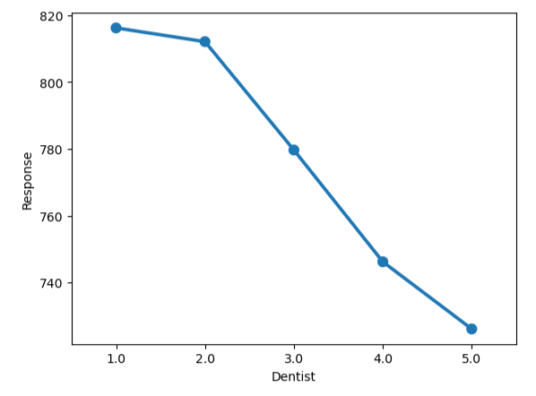

**Insights:**

* Dentist 1 has the highest response rate when compared with other dentists.
* Dentist 5 has least response rate.
* There is a decline in response rate from Dentist 1 to 5.

**CONCLUSION: DENTIST_3 and DENTIST_ 4 of ALLOY 1 type is a pair that di-ffers.**

**7.4** Now test whether there is any difference among the methods on the hardness of dental implant, separately for the two types of alloys. What are your conclusions? If the null hypothesis is rejected, is it possible to identify which pairs of methods differ?

**Ans:**

1. **Alloy 1:**

Ho = There is NO difference among the methods on the implant hardness

Ha = There is difference among the methods on the implant hardness

**Shapiro test:**

P value = **0.18198540806770325**

P value = **0.9030335545539856**

P value = **0.14254699647426605**

**Normally distributed as all p values are > 0.05**

**Levene test:**

P value **0.0034160381460233975**

**There is a significant difference between the variances (pvalue < 0.05)**

**Homogeneity:**



**Insight: Pair of methods that differ are 'Method_2 and Method_3' & 'Method_1 and Method_3' of ALLOY 1 type.**

**One Way Anova:**



As p value (0.004163) < α, we can Reject the null hypothesis. i.e., **There is difference among the methods on the implant hardness of Alloy 1 type.**

1. **Alloy 2:**

Ho = There is NO difference among the methods on the implant hardness

Ha = There is difference among the methods on the implant hardness

**Shapiro test:**

P value = **0.7582374811172485**

P value = **0.001051110913977027**

P value = **0.1025901660323143**

**Normally distributed as all p values are > 0.05**

**Levene test:**

P value 0.04469269939158668

**There is a significant difference between the variances (pvalue < 0.05)**

**Homogeneity:**



**Insight: Pair of methods that differ are 'Method_2 and Method_3' & 'Method_1 and Method_3' of ALLOY 2 type.**

**One Way Anova:**



As P value (0.000005) < α, we Reject the null hypothesis. i.e., **There is difference among the methods on the implant hardness of Alloy 2 type.**

**7.5** Now test whether there is any difference among the temperature levels on the hardness of dental implant, separately for the two types of alloys. What are your conclusions? If the null hypothesis is rejected, is it possible to identify which levels of temperatures differ?

**Ans:**

1. **Alloy 1:**

Ho = There is NO difference among the temperature level on the implant hardness

Ha = There is difference among the temperature level on the implant hardness

**Shapiro test:**

P value Temp_1500 = 0.001179991289973259

P value Temp_1600 =0.6869674324989319

P value Temp_1700 =0.0014549640472978354

**Only Temp_1600 is normally distributed as p value is > 0.05, T emp_1500 and Temp_1700 are not normally distributed as p value is < 0.05.**

**Levene test:**

P value 0.7686994896007937

**Variances are equal as p value is > 0.05**

**Homogeneity:**



**Insight: Temperatures of ALLOY 1 type don't differ, as all p values are > 0.05.**

**One Way Anova:**



**As p value > α, we Fail to Reject the null hypothesis. i.e., There is NO difference among the temperature level on the implant hardness of Alloy 1 type.**

1. **Alloy 2:**

Ho = There is NO difference among the temperature level on the implant hardness

Ha = There is difference among the temperature level on the implant hardness

**Shapiro test:**

P value Temp_1500 = 0.5280351042747498

P value Temp_1600 = 0.052296675741672516

P value Temp_1700 = 0.003997983876615763

**Temp_1500 and Temp_1600 is normally distributed as p value is > 0.05, and Temp_1700 is not normally distributed as p value is < 0.05.**

**Levene test:**

P value 0.5171946653062957

**Variances are equal as p value is > 0.05**

**Homogeneity:**



**Insight: Temperatures of ALLOY 2 type don't differ, as all p values are > 0.05.**

**One Way Anova:**

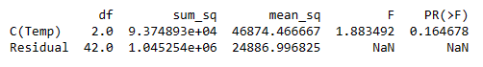

**As p value > α, we Fail to Reject the null hypothesis. i.e., There is NO difference among the temperature level on the implant hardness of Alloy 2 type.**

**7.6** Consider the interaction effect of dentist and method and comment on the interaction plot, separately for the two types of alloys?

**Ans:**

1. **Alloy 1:**

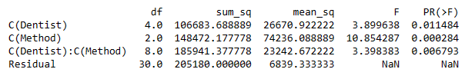

1. **Ho = There is NO effect of Dentists on the implant hardness**

**Ha = There is effect of Dentists on the implant hardness**

F statistic is 3.899638

As the p value **(0.011484)** of Dentists < α, we can Reject the null hypothesis.

i.e., of Alloy 1 type, there is effect of Dentists on the implant hardness.

1. **Ho = There is NO effect of Methods on the implant hardness**

**Ha = There is effect of Methods on the implant hardness**

F statistic is 10.854287

As the p value **(0.000284)** of Methods < α, we can Reject the null hypothesis.

i.e., of Alloy 1 type, there is effect of Methods on the implant hardness.

1. **Ho = There is NO interaction between Dentists and Methods on the implant hardness**

**Ha = There is an interaction between Dentists and Methods on the implant hardness**

F statistic is 3.398383

As the p value **(0.006793)** of Methods < α, we can Reject the null hypothesis.

i.e., of Alloy1 type, there is an interaction between Dentists and Methods on the implant hardness.

**Interaction plot:**

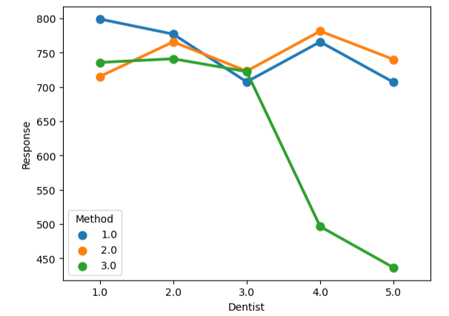

**Insights:**

* Interaction between Dentist 1 and Method 1 has the highest response rate.
* Dentist 5 with Method 3 has the least response rate.
* Overall, method 3 has the lesser response rate when compared with other methods.
* Method 2 has the higher response rate with dentist 2.

1. **Alloy 2:**

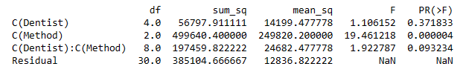

1. **Ho = There is NO effect of Dentists on the implant hardness**

**Ha = There is effect of Dentists on the implant hardness**

F statistic is 1.106152

As the p value **(0.371833)** of Dentists > α, we Fail to Reject the null hypothesis.

i.e., for Alloy 2 type, there is NO effect of Dentists on the implant hardness.

1. **Ho = There is NO effect of Methods on the implant hardness**

**Ha = There is effect of Methods on the implant hardness**

F statistic is 19.461218

As the p value **(0.000004)** of Methods < α, we can Reject the null hypothesis.

i.e., for Alloy 2 type, there is effect of Methods on the implant hardness.

1. **Ho = There is NO interaction between Dentists and Methods on the implant hardness**

**Ha = There is an interaction between Dentists and Methods on the implant hardness**

F statistic is 1.922787

As the p value **(0.093234)** of Methods > α, we Fail to Reject the null hypothesis.

i.e., for Alloy2 type, there is NO interaction between Dentists and Methods on the implant hardness.

**Interaction plot:**

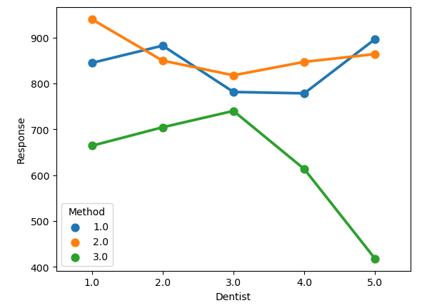

**Insights:**

* Interaction between Dentist 1 with Method 2 has the highest response rate.
* Dentist 5 with Method 3 has the least response rate.
* Overall, method 3 has the lesser response rate when compared with other methods.
* Among Dentists with Method 1, dentist 5 has the higher response rate.

**7.7** Now consider the effect of both factors, dentist, and method, separately on each alloy. What do you conclude? Is it possible to identify which dentists are different, which methods are different, and which interaction levels are different?

**Ans:**

1. **Alloy 1:**

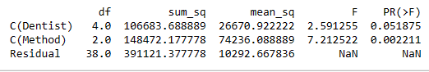

**Two Way Anova without interaction**

1. Ho = There is NO difference among the dentists on the implant hardness.

Ha = There is difference among the dentists on the implant hardness.

**As p value 0.051875 > α, we Fail to Reject the null hypothesis. Therefore, there is NO difference among the dentists on the implant hardness for Alloy 1 type (No interaction).**

1. Ho = There is NO difference among the Methods on the implant hardness.

Ha = There is difference among the Methods on the implant hardness.

**As p value 0.002211 < α, we should Reject the null hypothesis. Therefore, there is difference among the Methods on the implant hardness for Alloy 1 type (No interaction).**

**Two Way Anova with interaction**

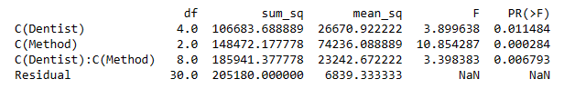

1. Ho = There is NO difference among the dentists on the implant hardness.

Ha = There is difference among the dentists on the implant hardness.

**As p value 0.011484 < α, we should Reject the null hypothesis. Therefore, there is difference among the dentists on the implant hardness for Alloy 1 type.**

1. Ho = There is NO difference among the Methods on the implant hardness.

Ha = There is difference among the Methods on the implant hardness.

**As p value 0.000284 < α, we should Reject the null hypothesis. Therefore, there is difference among the Methods on the implant hardness for Alloy 1 type.**

1. Ho = There is NO difference among the interaction levels on the implant hardness.

Ha = There is difference among the interaction levels on the implant hardness.

**As p value 0.006793 < α, we should Reject the null hypothesis. Therefore, there is difference among the interaction levels on the implant hardness for Alloy 1 type.**

1. **Alloy 2:**

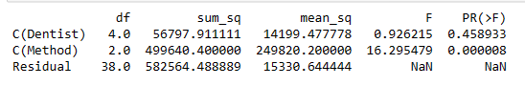

**Two Way Anova without interaction**

1. Ho = There is NO difference among the dentists on the implant hardness.

Ha = There is difference among the dentists on the implant hardness.

**As p value 0.458933 > α, we Fail to Reject the null hypothesis. Therefore, there is NO difference among the dentists on the implant hardness for Alloy 2 type. (No interaction)**

1. Ho = There is NO difference among the Methods on the implant hardness.

Ha = There is difference among the Methods on the implant hardness.

**As p value 0.000008 < α, we should Reject the null hypothesis. Therefore, there is difference among the Methods on the implant hardness for Alloy 2 type (No interaction).**

**Two Way Anova with interaction**

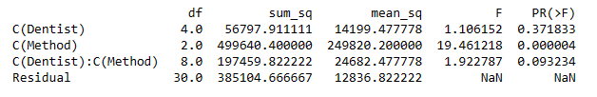

1. Ho = There is NO difference among the dentists on the implant hardness.

Ha = There is difference among the dentists on the implant hardness.

**As p value 0.371833 > α, we Fail to Reject the null hypothesis. Therefore, there is NO difference among the dentists on the implant hardness for Alloy 2 type.**

1. Ho = There is NO difference among the Methods on the implant hardness.

Ha = There is difference among the Methods on the implant hardness.

**As p value 0.000004 < α, we should Reject the null hypothesis. Therefore, there is difference among the Methods on the implant hardness for Alloy 2 type.**

1. Ho = There is NO difference among the interaction levels on the implant hardness.

Ha = There is difference among the interaction levels on the implant hardness.

**As p value 0.093234 > α, we Fail to Reject the null hypothesis. Therefore, there is NO difference among the interaction levels on the implant hardness for Alloy 2 type.**